Purpose
The second week of RUN InnoBoost bootcamps is organized by HAMK University of applied sciences. The week is mainly divided into 3 parts:
1. How To Innovate
2. Design Thinking
3. Design Sprint
The purpose of How To Innovate is to gain basic understanding and knowledge on methods and tools regarding innovation. After the part, the students understand, and can explain a process on how to innovate and understand how to use use AI sustainably as an innovation assistant. This part enhances the students’ innovation capabilities and helps them understand various roles and skills in innovative teams through Innovation cards
The purpose of Design Thinking is to gain basic understanding of the design thinking approach to problem-solving and innovation. After the part, the students understand and can explain the design thinking approach and how it relates to innovation. This part enhances students’ creative thinking capabilities and helps them to understand whta possibilities and constraints design thinking approach has for problem-solving and innovation. The students get an empirical point-of-view of the approach.
The purpose of Design Sprint is to understand the Design Sprint development method, ways to implement it in fast development projects and the steps included in the method. After the part, the students understand and can explain the Design sprint methodology. This part enhances the students’ understanding of agile and fast development, the possibilities included but also the limitations and constraints it has. The students get an empirical point-of-view of the development method.

Materials
Materials for the online week can be found from innoboost.eu, under their respective locations. The materials include online lecturers and documents related to them, learning videos, case study articles and other various materials.

Step-by-step guide for student
The Online week is divided into 3 parts. Each part has their own small learning tasks to be done, with instructions on how to succeed on them. The tasks are done individually. Student must pass all the given tasks to gain a PASS grade from the week. The week is graded as a whole.
HAMK’s Online BootCamp week is hosted during week 39. The assignments should be submitted to innoboost@hamk.fi per the instructions available on www.innoboost.eu and in the lecture materials.
Use of AI
AI usage guidelines
The week follows the guidelines of ARENE, The Rectors’ Conference of Finnish Universities of Applied Sciences. The guidelines can be found from https://arene.fi/wp-content/uploads/PDF/2024/Teko%C3%A4lysuositukset/Arene%E2%80%99s%20recommendations%20on%20the%20use%20of%20artificial%20intelligence%20for%20uni-versities%20of%20applied%20sciences%202024.pdf
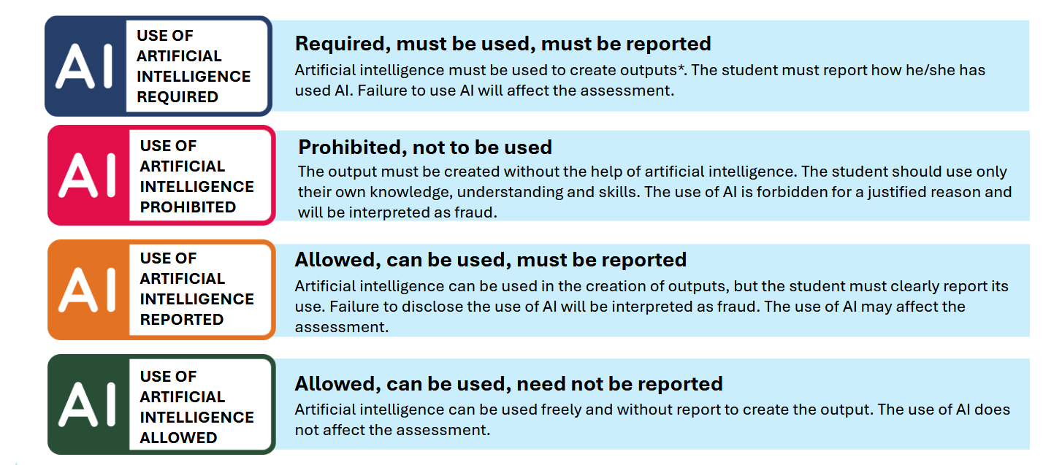
Picture 1. Visual instructions on how AI can be used in various assignments (ARENE, n.d.)
Using Artificial Intelligence gives us multiple possibilities, and is a skill that the students should have, but it cannot take learning responsibility from the student. Thus, using AI ethically is a skill needed for you also in your later studies. For more instructions, please visit https://digipedaohjeet.hamk.fi/ohje/artificial-intelligence-user-reminder-list-for-students/?lang=en.
NOTE: unethical AI usage can be seen as plagiarism meaning the work will not be graded.
Instructions on how to use AI during HAMK’s online BootCamp assignments

Use of artificial intelligence is allowed, can be used, must be reported, may affect assessment: Artificial intelligence can be used in the creation of outputs, but the student must clearly report its use. Failure to disclose the use of AI will be interpreted as fraud. Using AI ethically and reporting it consistently is expected.

Guidance and feedback
During Monday, Tuesday, Wednesday and Friday at 1 PM (EET), there are allocated guidance sessions in which the course teachers will be assisting you in your studies. The links to the sessions can be found from https://innoboost.eu/run-innoboot-camp/

Evaluation
Evaluation will be done during and after the submission period, at the latest on week 51. The evalution order is prioritized so, that students willing to join InnoBoost Bootcamps in Stenden and TUS are prioritized.
The evaluation is PASS/FAIL. The evaluation takes into consideration the various level of students, as we have students from EQF 6 to EQF 8 levels.

Evaluation criteria
Evaluation has 4 parts from which at least 3 must be submitted per instructions in order for a student to gain a PASS grade.
Part 1: The student submits a detailed learning report of their findings, their own analysis of innovation as a method, and inno cards. The report is referenced based on the HAMK referencing guide. The report can include pictures
Part 2: The student submits a detailed learning report of their findings and own analysis of Design Thinking based on the course material. The report is referenced based on the HAMK referencing guide. The report can include pictures
Part 3: The student submits a detailed learning report of their findings and analysis of Design Sprint as a development method. The report is referenced based on the HAMK referencing guide. The report can include pictures
Part 4. Case Study: The students analyse the articles on the topic and explain how design thinking, design sprints, and innovation methods are represented in the material. The report can include pictures

Link to working life
Working life is directly related and presented in the topics and case studies of the course.

Schedule and timing
The Online week has 9 hours of contact sessions and guidance meetings. In addition to the contact sessions, the individual learning tasks are planned to take 10 hours of individual learning time, totalling the time allocation to 19 hours for the whole week.

Connection to the next assignment
Student must pass all assignments in order to gain a grade PASS. HAMK’s InnoBootCamp week is directly related to the weeks of NHL Stenden and TUS

